**INSERT** **INTO** employees **VALUES**(1,'Finding','Nemo','Nemo@email.com');

**INSERT** **INTO** employees **VALUES**(2,'Peace','Harmony','Peace@email.com');

**INSERT** **INTO** employees **VALUES**(3,'Varun','Shashtri','Varun@email.com');

**INSERT** **INTO** employees **VALUES**(4,'Peter','DSouza','Peter@email.com');

**INSERT** **INTO** employees **VALUES**(5,'Pradeep','Kumar','PK@email.com');

**INSERT** **INTO** employees **VALUES**(6,'Roshan','Rakesh','r2r@email.com');

**INSERT** **INTO** employees **VALUES**(7,'John','Fernandes','John@email.com');

* Insert into: http://localhost:8080/employees

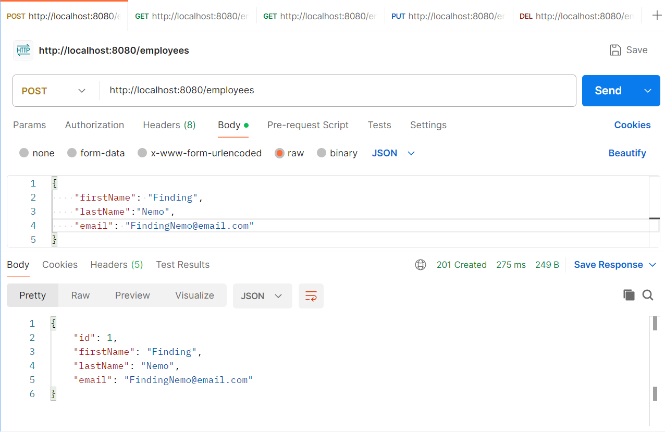

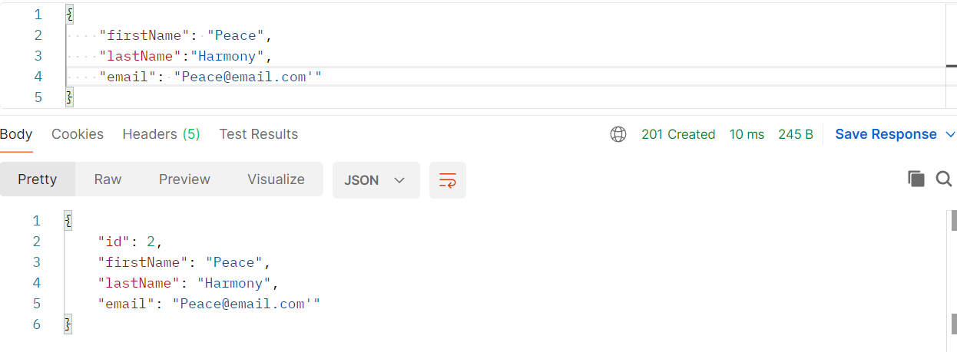

* Get All Employees: http://localhost:8080/employees

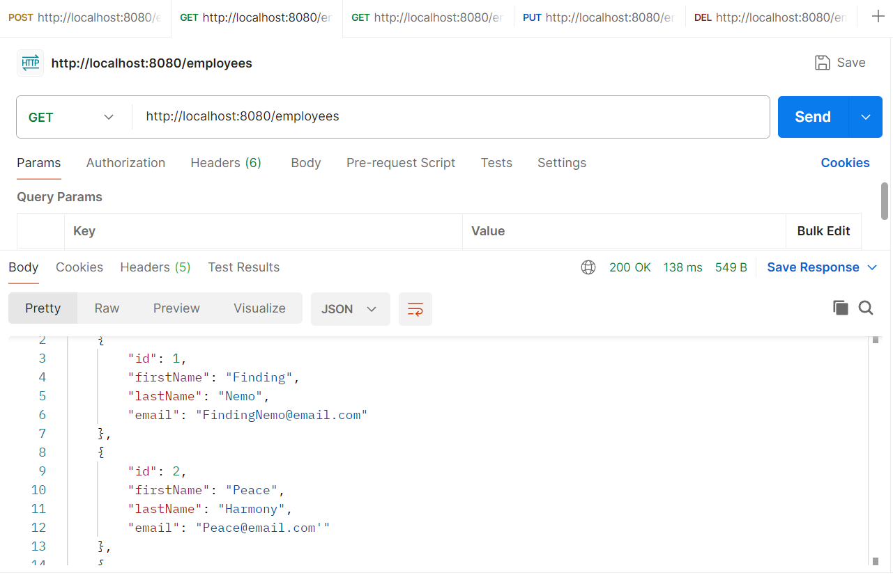

[

    {

        "id": 1,

        "firstName": "Finding",

        "lastName": "Nemo",

        "email": "FindingNemo@email.com"

    },

    {

        "id": 2,

        "firstName": "Peace",

        "lastName": "Harmony",

        "email": "Peace@email.com'"

    },

    {

        "id": 3,

        "firstName": "Varun",

        "lastName": "Shashtri",

        "email": "Varun@email.com"

    },

    {

        "id": 4,

        "firstName": "Peter",

        "lastName": "DSouza",

        "email": "Peter@email.com'"

    },

    {

        "id": 5,

        "firstName": "Pradeep",

        "lastName": "Kumar",

        "email": "PK@email.com"

    }

]

* Update employee id 2 from Peace Harmony to Kumaran Patil

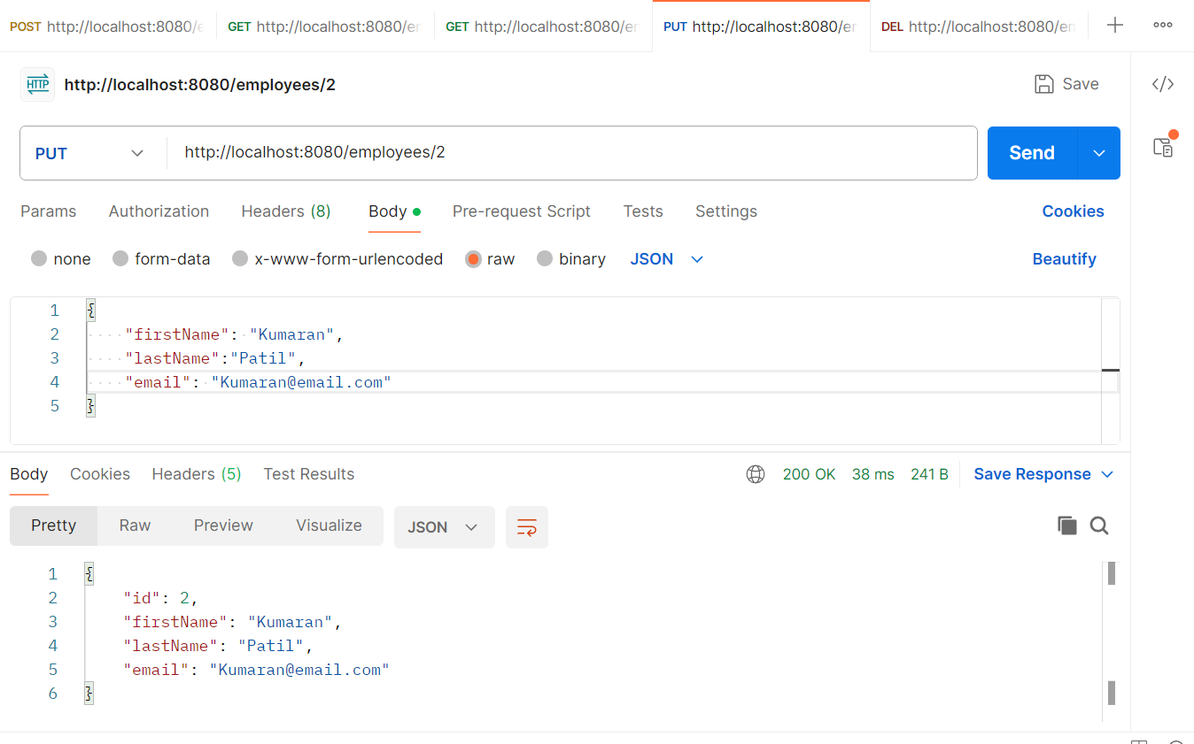

* Search Employee by Id 2: http://localhost:8080/employees/2

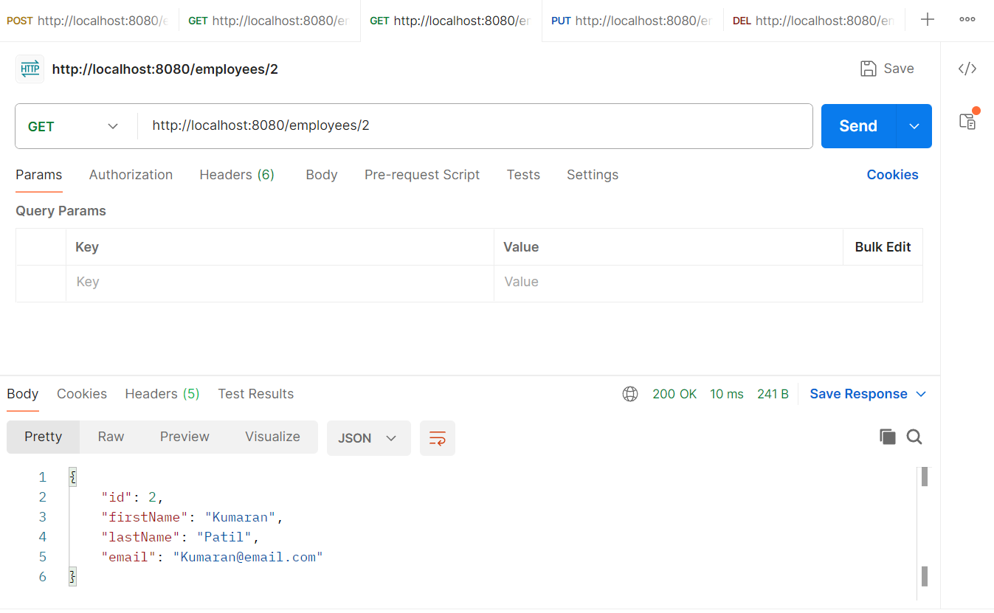

* Deleting Employee id 2 : http://localhost:8080/employees/2

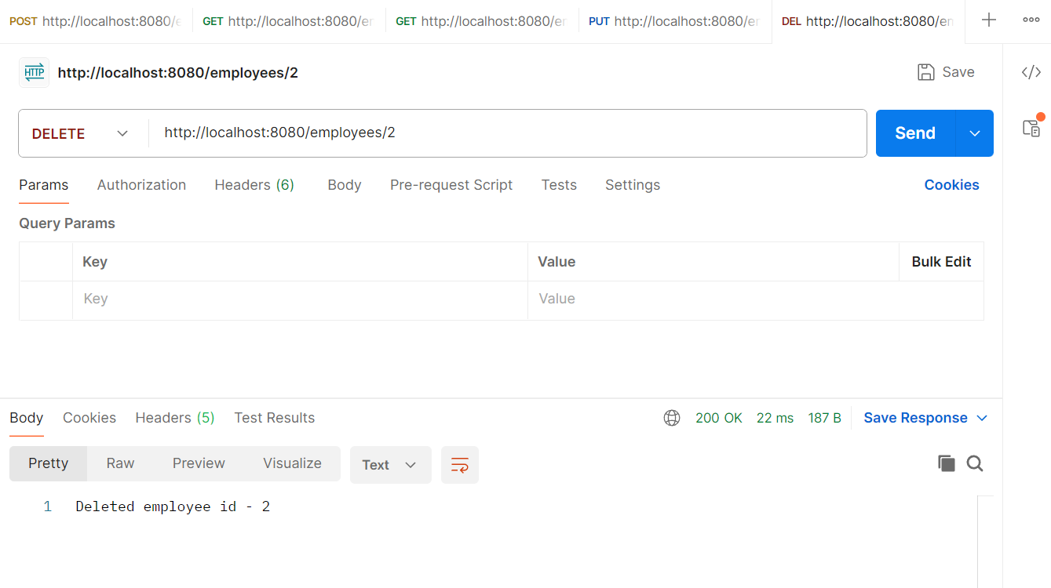

* fetch an employee by his/her first name Pradeep

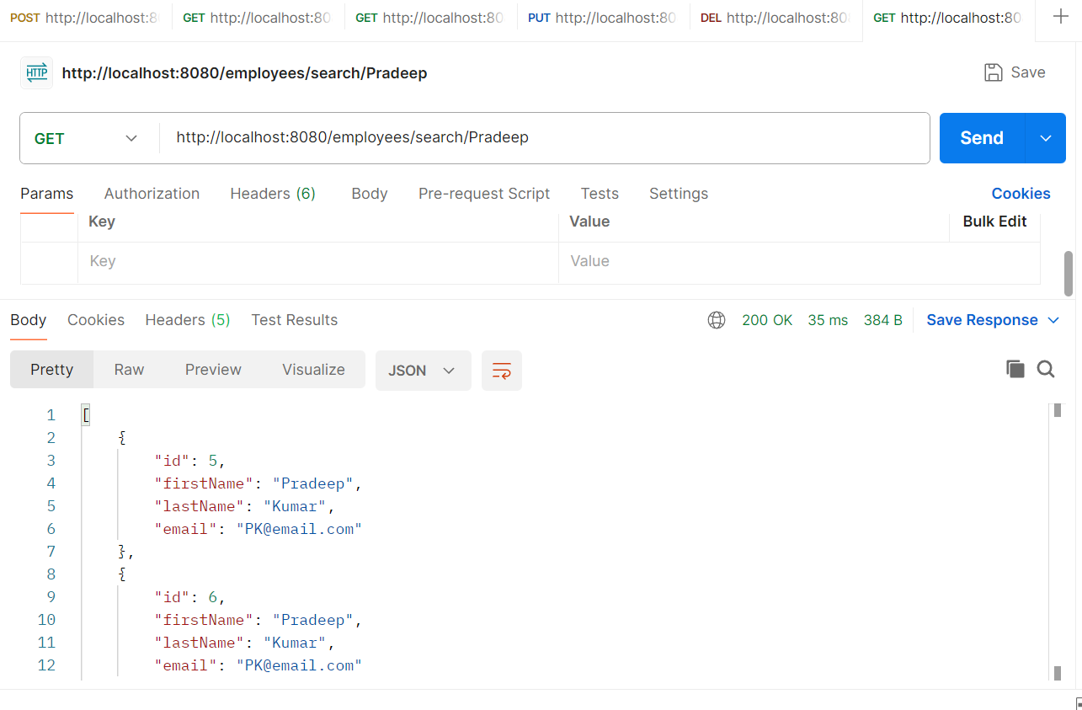

* Sort by Descending order: http://localhost:8080/employees/sort?order="desc"

